 

**University of Westminster**

**Software Development I**

**4COSC006C**

TEST PLAN

Part 1

Name – Shivanka Vindunie Maddumarachchi

UOW Number – w2051745

IIT Number - 20230684

|  |
| --- |
| **4COSC006C: Software Development I** **– TEST PLAN for Part 1** Student Name/ID: Shivanka Vindunie Maddumarachchi  w2051745  20230684    Seminar Day/Time: Module Tutor: |

**Test Case Table**

|  |  |  |  |  |  |
| --- | --- | --- | --- | --- | --- |
|  | **Student Name: Shivanka Maddumarachchi**   **Student ID: 20230684** | | | | |
|  | **TEST PLAN for Part 1 :** Submit completed test plan with your code solution | | | | |
| **Test Component** | **Test No.** | **Test Input** | **A - Expected Result** | **B - Actual Result**  **(or state ‘not attempted’)** | **Pass/Fail**  **(‘A’ matches ‘B’ == Pass)** |
| Progress | 1 | Pass = 120  Defer = 0  Fail = 0 | ‘Progress’ displayed | ‘Progress’ displayed | Pass |
| Progress (module trailer) | 2.1 | Pass = 100  Defer = 20  Fail = 0 | ‘Progress (module trailer)’ displayed | ‘Progress (module trailer)’ displayed | Pass |
| 2.2 | Pass = 100  Defer = 0  Fail = 20 | ‘Progress (module trailer)’ displayed | ‘Progress (module trailer)’ displayed | Pass |
| Module retriever | 3.1 | Pass = 80  Defer = 20  Fail = 20 | ‘Module retriever’ is displayed | ‘Module retriever’ is displayed | Pass |
| 3.2 | Pass = 60  Defer = 0  Fail = 60 | ‘Module retriever’ is displayed | ‘Module retriever’ is displayed | Pass |
| 3.3 | Pass = 40  Defer = 80  Fail = 0 | ‘Module retriever’ is displayed | ‘Module retriever’ is displayed | Pass |
| 3.4 | Pass = 20  Defer = 40  Fail = 60 | ‘Module retriever’ is displayed | ‘Module retriever’ is displayed | Pass |
| 3.5 | Pass = 0  Defer = 60  Fail = 60 | ‘Module retriever’ is displayed | ‘Module retriever’ is displayed | Pass |
| Exclude | 4.1 | Pass = 40  Defer = 0  Fail = 80 | ‘Exclude’ displayed | ‘Exclude’ displayed | Pass |
| 4.2 | Pass = 20  Defer = 0  Fail = 100 | ‘Exclude’ displayed | ‘Exclude’ displayed | Pass |
| Validation | 5.1 | Pass = a | ‘Integer required’ | ‘Integer required’ | Pass |
| 5.2 | Pass = 5 | ‘Out of range’ | ‘Out of range’ | Pass |
| 5.3 | Pass = 100  Defer = 40  Fail = 0 | ‘Total incorrect’ displayed | ‘Total incorrect’ displayed | Pass |
| Loops for multiple inputs | 6.1 | Program loops | Predicts multiple progression outcomes | Stored multiple progression outcomes | Pass |
| 6.2 | Enter ‘q’ | Exits loop | Exits loop | Pass |
| Histogram | 7.1 |  | Window pops up and renders graph. Includes values for Progress, Trailer, Retriever and Excluded | Window pops up and renders graph. Includes values for Progress, Trailer, Retriever and Excluded | Pass |
| 7.2 |  | Shows outcomes in total. | Shows outcomes in total. | Pass |

**Test Cases Screenshots**

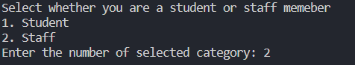

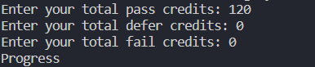

*Figure 1: Progress*

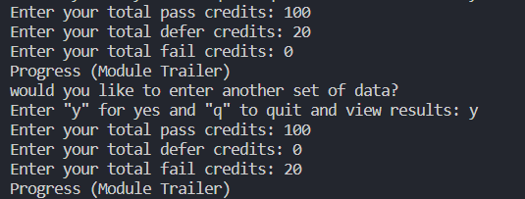

*Figure 2: Progress (module trailer)*

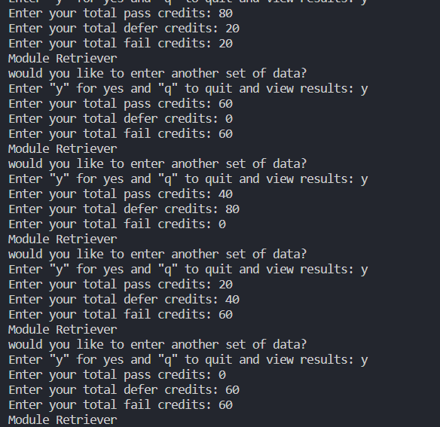

*Figure 3: Do not Progress – module retriever*

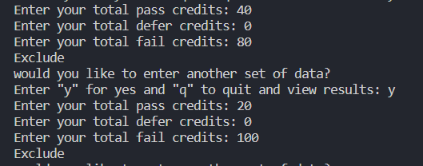

*Figure 4: Exclude*



*Figure 5: Validation 5.1*



*Figure 6: Validation 5.2*

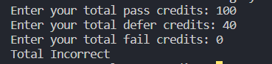

*Figure 7: Validation 5.3*

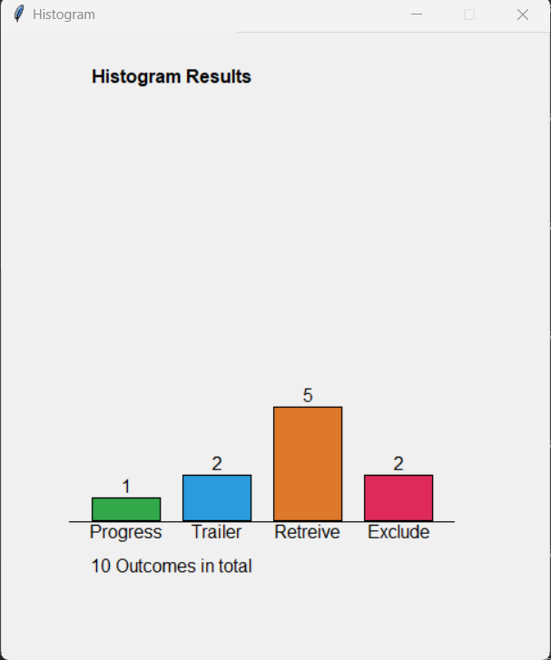

*Figure 8: Histogram 7.1*



*Figure 9: Histogram 7.2*